FABI

... the Flexible Assistive Button Interface

“Do-It-Yourself” - Building Guide

& User Manual



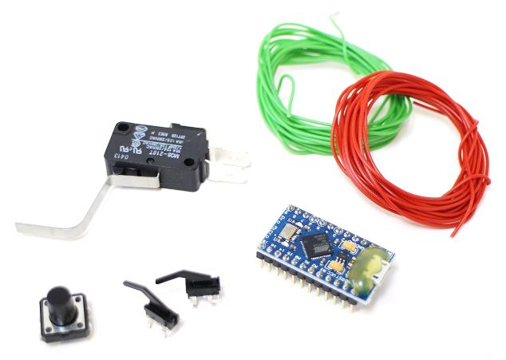

# 

# Welcome to FABI

The FABI (Flexible Assistive Button Interface) allows control of a computer’s mouse cursor and typing desired keyboard keys by using buttons and special/individual input methods. It can be helpful for people who cannot use standard computer input devices – enabling them to play games, surf the internet, write emails and much more.

The FABI Interface can be actuated via dedicated buttons, momentary switches or self-made electrical contacts. FABI consists of a hardware module (a low-cost microcontroller which behaves as a computer mouse and/or keyboard) and a graphical software application for configuration of the desired functions.

This user manual includes a “do-it-yourself” building guide for your personal FABI device, describing the necessary hardware components and the Graphical User Interface application for the configuration of the different functions. A configured FABI module can be used on any computer (Windows, Linux or Mac) without installation of special software, because the FABI module behaves exactly like a standard mouse and keyboard which is plugged into your computer. Nevertheless, for configuring the desired functions via the GUI application a driver installation is necessary. The driver installation is also explained in the software section of this manual.

FABI is an open source Assistive Technology module developed by the AsTeRICS Academy Project of the University of Applied Sciences, Technikum Wien

(see <http://www.asterics-academy.net>).

All software and hardware plans are open source and we took care to use the most affordable components available on the market to establish these functionalities – making FABI the most reasonably priced flexible assistive button interface we know !!

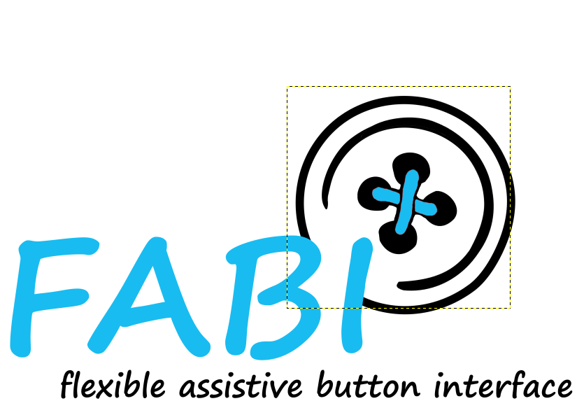.

# Contents

Welcome to FABI 2

Contents 3

Building the Hardware 5

Make your own Switches 9

Soldered connections to the microcontroller 12

Building you own FABI Box 14

Using the Software 18

Placing the firmware into the microcontroller 18

Using the FABI GUI application 21

Selection of function for Button/Switch actions 25

List of needed Material 28

Download Links and Contact 29

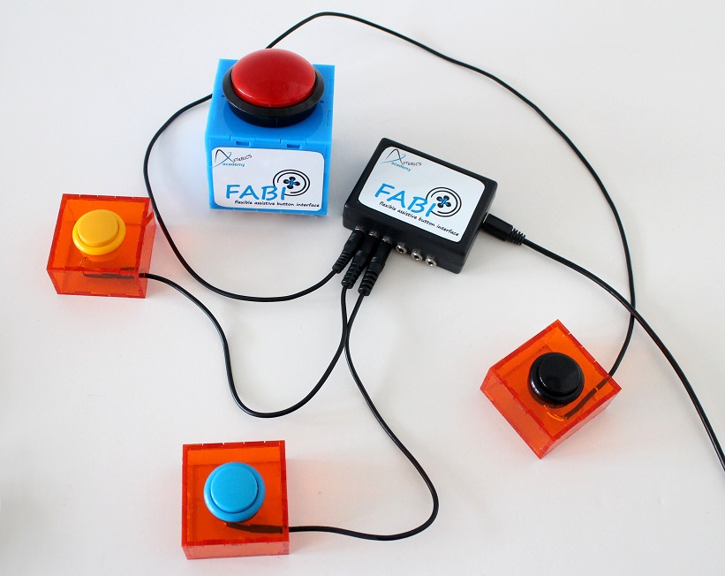

# Building the Hardware

Building your own FABI interface for computer control is easy ! Here, we will show what you need and how to assemble the parts, and we will give some ideas how to build your own alternative input variants using creative low tech solutions.

A working FABI device consists of a microcontroller with USB cable and some additional electrical connections (wires, switches, buttons) – which can be mounted in a way so that they are easily accessible for the user(s).

#### The microcontroller

The microcontroller is the “brain” of the FABI interface. It monitors which button a user presses and creates the desired/associated mouse- or keyboard activities! The microcontroller is a programmable electronic circuit (actually a small computer on a chip) which can execute the programmed software and performs measurement- and control tasks. Theoretically, various microcontrollers could be used to build a FABI interface – as long as they support the USB HID protocol which makes them compatible to computer mouse- or keyboard devices. In our project, we decided to use an Arduino Pro Micro controller for circa US-$ 4,50 ! This microcontroller has a USB-Port where it can be connected to any computer (Windows, Mac, Linux).

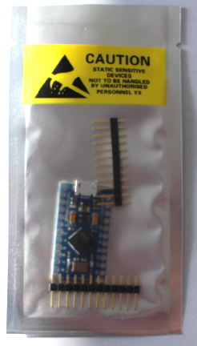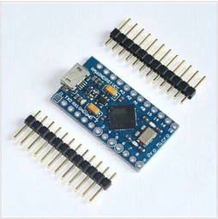

Figure 1: example of Arduino Pro Micro clone which can be used (4,50 $),

We created the necessary software which is now available as open source and can be stored into the microcontroller using the free Arduino Integrated Development Environment. The process of programming the microcontroller is described later in the software section of this manual.

#### Using breadboards for prototyping

The easiest way to connect electrical components (as for example wires and switches) to the microcontroller is a breadboard. A breadboard has mounting holes for components or wires, as well as internal electrical connectors called “bars” and “rails”: The bars are connected vertically (expect for the bridge in the middle) and the rails are connected horizontally, see figure below (right). The black mini breadboard shown on the photo below (left) features only bars, no rails.

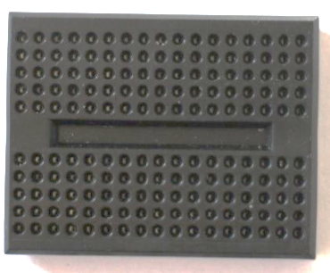 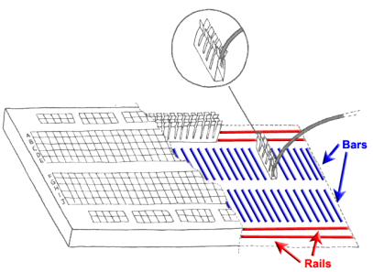

Figure 2: a minimal Breadboard (left), internal connections of a breadboard (right)

Breadboard prototypes are especially useful if you don’t want to use your construction for long or you want to experiment a lot, because the connections are very flexible and easily changeable. For long-term usage, a soldered construction should be used because it’s more robust – especially when you found a reasonable assistive configuration which helps other persons !

When you buy a “naked” Arduino Pro Micro microcontroller from a shop or online store, you probably must solder so-called “pin headers” to the pin holes before you can insert the microcontroller into the breadboard. Afterwards you can connect wires to the desired pins via the breadboard. A controller with pin header connectors attached looks similar to this:

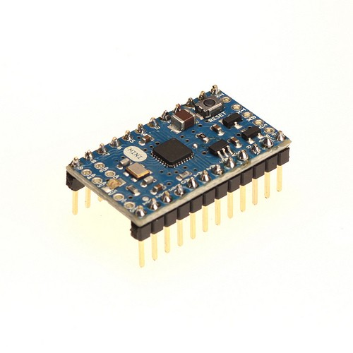

Figure 3: A microcontroller (here: Arduino mini) with pin header connectors attached

#### The basics of soldering

The usage of a soldering iron for connecting electric/electronic components is easy - if you pay attention to a few things:

**Safety Rules:**

* **Never touch the tip of the soldering iron**- it gets over 200^C!
* **If you use solder with lead, pay attention that it is not touching your skin and that you do not inhale it**- Lead is poisonous
* **Put the soldering Iron always back into its stand**
* **Always pay attention to what you are doing**!

1. Hold the soldering iron in your dominant hand (like you would hold a pencil). In your other hand you hold the solder
2. Touch the cleaned tip the lead solder and the part where you want to connect something
3. Add about 1mm to 3mm of solder under the tip
4. Add the other part you want to connect with the part one

|  |  |  |
| --- | --- | --- |
|  |  |  |

Figure 4: Basic steps of soldering

#### Soldering the pin header to the controller:

Cut 2 male pin headers to the correct length for the microcontroller (if not already provided), put the small ends through the connector holes of the controller and fix the three parts in a stable position for soldering. Maybe the best idea is to put everything already into the breadboard which gives a good stability. (don’t touch the pin header connections while solder – yes – they get hot ;-)

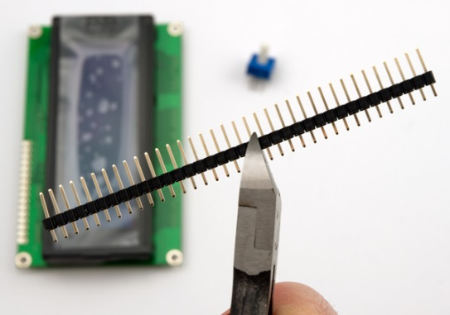 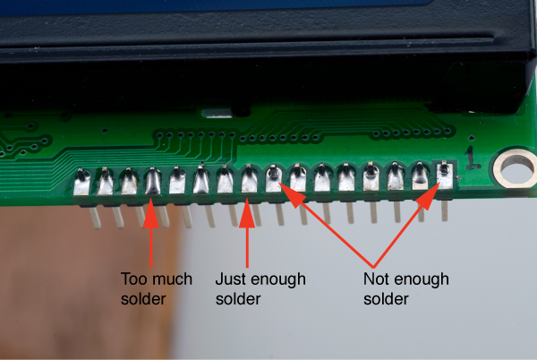

Figure 5: Cutting the male pin header, applying right amount of solder

#### Attaching wires to the microcontroller:

For connecting a switch to the microcontroller we need to attach one wire to the ground potential (zero volts, labelled “GND” at the microcontroller). Then we attach another wire to another “Pin” – you can choose one from 2-7 as these are supported in the software. At this pin connections, the microcontroller then receives the ground potential when the switch will be pressed.

**Remove the isolation from the wires on both ends, so that you can insert the bare metal wire into the breadboard. Make sure that at least 5mm bare wire goes into the breadboard connection.**

The finalized microcontroller with soldered pins and two attached wires should now look similar to this:

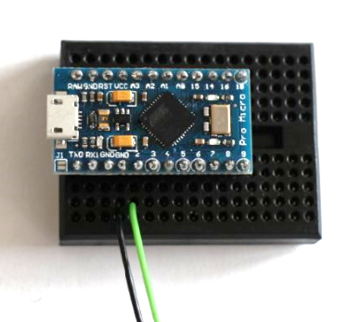

Figure 6: How to connect wires with microcontroller,   
here using a breadboard: black wire for GND pin, green wire for input / signal pin 2

The FABI software is programmed so that we can use any pin from 2 to 7 to attach the ground potential. The microcontroller will then react by performing one out of 6 functions which can be defined in the configuration software**.**

The two bare wire ends which now stand off can act as a simple switch: By connecting them you trigger the signal to the microcontroller so that the desired actions can be performed. This represents the most basic switch possible …

## Make your own Switches

Switches are a simple method for computer control – if supported well in the computer software and/or operating system. Accessible switches are supported by various kinds of assistive software applications like On-Screen-Keyboards or Alternative Augmented Communication grids. A standard accessible switch (without the computer control box) can cost 100 $ or more if you buy it from a professional reseller – this is 10 times the cost of our whole FABI device ….

Switches attached to FABI can create many different computer input actions like all kinds of mouse clicks, mouse movement and more (see the software section for details). The only things you need to add to your microcontroller are suitable wire connections and switch contacts for the user. In the following, a few simple ways to create different switch contacts will be presented:

#### The most simple switch: Two connected wires !

The simplest switch is built of two wires which are connected to pin and to the ground pin (GND) of the microcontroller. If the two wires do not touch each other, there is connection between the two pins and no signal is received. If the two wires touch each other, the resistance is decreased and the microcontroller receives the ground signal – so it can detect that the button was pressed.

|  |  |
| --- | --- |
| No Signal | Signal |
|  |  |

Figure 7: Simple switch made out of two wires, left picture: switch is inactive; right picture: switch is activated

#### Cardboard / foil - switch

The cardboard / foil switch works the same way as the simple wire connection described above, but it is more user friendly because you can use the cardboard as a haptic momentary contact switch and press it witch different limbs / fingers / even toes ! – And: it costs next to nothing !

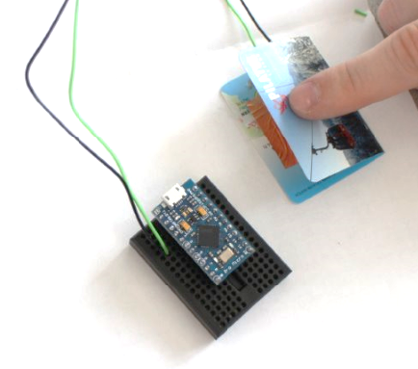

Figure 8: Cardboard / foil switch

Here we used copper foil (or aluminum foil) and a piece of thick paper (e.g. a business card of someone you will never contact ;-) to build the accessible switch:

|  |  |  |
| --- | --- | --- |
|  |  |  |

Figure 9: material for low tech switch: left picture: piece of carton, middle picture: copper foil, right picture: switch wire

Fold the carton in the middle like in figure 8. Afterwards stick the two pieces of foil, one of each side of the inner areas of the cartoon including a wire between cartoon and foil on each side (see figure 10).

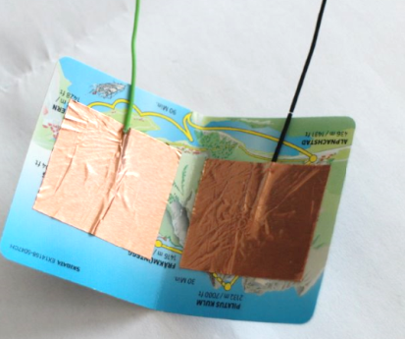

Figure 10: copper foil and the two wires stick on the inner side of the cartoon

Now connect the wire to the microcontroller like in figure 8. By pressing the upper side of the cartoon to the underside of the cartoon together that the two foil pieces can connect, the switch is activated. For mounting the cardboard / foil switch in a convenient position, velcro-tape or double-sided sticky tape could be reasonable methods …

#### Re-using an existing switch

There are various possibilities for finding switches in old electrical or household devices. In fact, all you need are two metal contacts ! – You can use an old light switch or an on/off switch of an old radio – the options are endless. Here we show a microswitch which can be found e.g. in several computer joysticks. Of course you can also buy one from the store ;-)

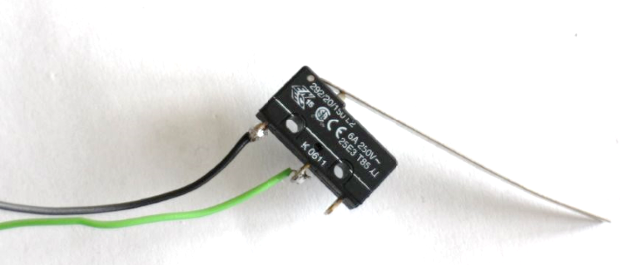

Figure 11: (Re-)using an existing switch

To solder the wires to the switch, the best is to fixate the switch in a vice. Then connect the wires to the switch using solder, as shown in figure 12.

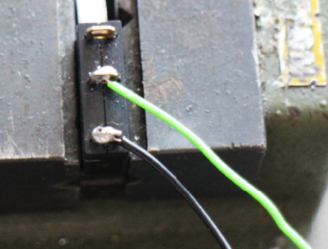

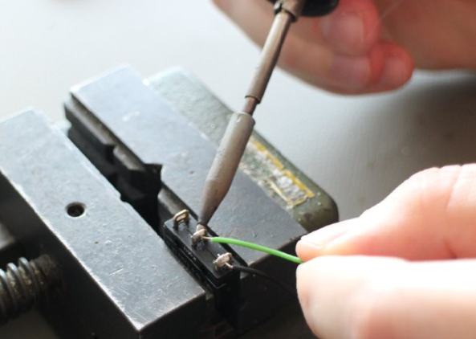

Figure 12: how to solder the wires to the switch

## Soldered Connections

If you want to use your device for a longer period or you found a helpful configuration for another person, your solution should be very robust and stable. It will be a good idea to remove the breadboard and solder the wire connection directly to the microcontroller.

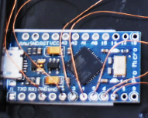

Figure 13: Wires are directly soldered to   
single pins of the microcontroller

For soldering, follow the basic soldering introduction above. Pay attention that you do not burn the device by applying too much heat to the pins (5 seconds at about 350 degC should be fine). The figure above shows a new microcontroller (without pre-soldered male pin headers). Here, enameled copper wire was used for the connections – you can also attach other wires of course but pay attention not to create short circuit connection to other pins via loose wire parts…

If you already attached the male pin headers, they will be difficult to remove. In this case it might be better to buy female pin header connectors where you can attach the microcontroller’s male pin headers. Thereby you create a stable but still removable connection and you can solder your wires to the female pin header connections.

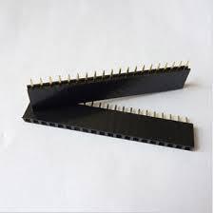 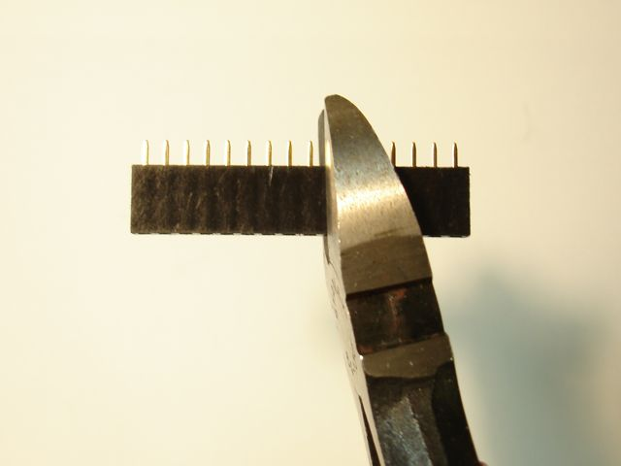

#### Connect switches via jack plugs and stereo cable

It might be reasonable to solder the wires from the microcontroller to a 3,5mm stereo (or mono) jack plug. With this solution you have the possibility to connect a variety of input methods to the jack plug via a stereo audio cable. You could also connect standard accessible switches which (most probably) come with a 3,5mm mono jack plug.

Solder one wire to a GND-pin of the microcontroller and another wire to the desired input pin (labelled 2 – 7 in case of the Arduino Pro Micro). The other end is soldered to the 3,5mm jack plug as shown in figure 14: The long end of the jack plug should be connected to the ground wire on of the shorter end to the pin-wire. Now you can easily connect any device with a stereo cable to your jack plug.

|  |  |
| --- | --- |
| Receive Pin  GND |  |

Figure 14: left picture: jack plug, right picture: stereo cable

|  |  |
| --- | --- |
|  |  |

Figure 15: how to solder two wires to a stereo plug

Unscrew the tip of the jack plug. Then connect the ground wire and pin wire as shown in the left pictures above using the soldering iron. After successfully finishing the soldering step, you can screw the housing of the stereo cable as shown in the right picture above.

## Building you own FABI Box

|  |  |
| --- | --- |
|  | Figure 16: FABI box |

If you would like to protect your microcontroller in a nice case and add flexible connectors, it might be an idea to build a FABI box with 6 jack plugs, to connect 6 different switches to the microcontroller pins 2, 3,4,5,6 and 7. These 6 switches can then be configured with the FABI GUI software for different alternative computer control functions as explained in next chapter “software”.

|  |  |
| --- | --- |
|  | The first step to build a FABI box is to mark the drill holes for the 6 jack plugs (long side of the box) and the USB connection (short side of the box).  It is important that the single jack plugs are far enough away from each other that the plugs can be inserted later. The distance between two plug holes should be at least 10mm. Pay attention that the holes are in the middle of the box! |
|  | Fix the box with the vice |
|  | With a pointed punch and a hammer the holes which should be drilled are marked for an easier handling with the big drill |
|  | After the preparation explained above, make the holes for the jack plug and the USB cable carefully with a stationary table driller (6mm drill)  But before using the drill, please read the user manual carefully!  Pay attention to your body especially the fingers! Always use the vice while working with the drill |
|  | Now the box should have 6 holes for the jack plugs and one bigger hole for the USB cable (can be extended with a file ) |
|  | Remove all disturbing plastic elevations inside the box |
|  | Strip the isolation off of a wire cable to get a bare conductive wire (length: ca. 7 cm) |
|  | Then you can start to screw the jack plugs into their mounting holes and connect their longer connections with the wire (this will supply the ground connection to all jack plugs).  (put the wire through the small holes in the longer end of the jack plug) |
|  | Solder the wire and the long ends of the jack plugs together |
|  | Now it is time to connect the single pins to the jack plugs. For these connections, enameled copper wire is used which is very thin and flexible.  For an electric connection it is necessary to remove the isolation from the ends of the copper wire. This can be done by adding solder and heating the ends several seconds with the soldering iron. Make sure that the isolation layer is 100% removed ! |
|  | Cut pieces of short copper wire and connect the single pieces to the pins (2-7):  Fill the pin hole on the microcontroller up with solder then heat the solder in the pin hole again and add the copper wire. Attention: it takes about one second till the solder is tight again; therefore you have to work fast and precise!  Then connect the copper wire from each pin to the dedicated jack plug (smaller end)  One copper wire is used to connect the bare wire (leading to every jack plug) with a GND pin of the microcontroller |
|  | In the end your result should look like the picture on the left side: every pin is connected to one jack plug end and the ground connection is also connected to the microcontroller  Now you can screw the cover to the box and download the software as described in the next section ! |

Figure 17: The finished guts of a FABI box

# Using the Software

The FABI hardware needs its proper software which provides all the functionalities. The FABI software is distributed as part of the AsTeRICS open source framework (<http://www.asterics.org>) and can be downloaded separately from the homepage of the AsTeRICS Academy project (<http://www.asterics-academy.net>). The software consists of the following two parts:

* **The software which runs in the microcontroller (the so-called “firmware”):   
  It creates the desired mouse and keyboard inputs for the attached computer**
* **The FABI GUI software application which runs on a Windows PC. It communicates with the software on the microcontroller and can be used for the configuration of the desired functions of the attached switches**

This chapter will describe the necessary steps to program the firmware into the microcontroller and the features of the FABI GUI application to setup your desired behavior of the FABI device !

For performing these steps you need to download the FABI software packages from the above sources. If you have any problems or questions regarding the software download or installation, just write us an email to [office@asterics-academy.net](mailto:office@asterics-academy.net)

## Placing the firmware into the microcontroller

For placing the firmware into the memory of the microcontroller (a process which is also called “flashing the firmware”), we will use the Arduino Integrated Development Environment. This has the advantage that you could also view and/or change the source code of the program if you are interested. The Arduino IDE can be downloaded from <http://www.arduino.cc>.

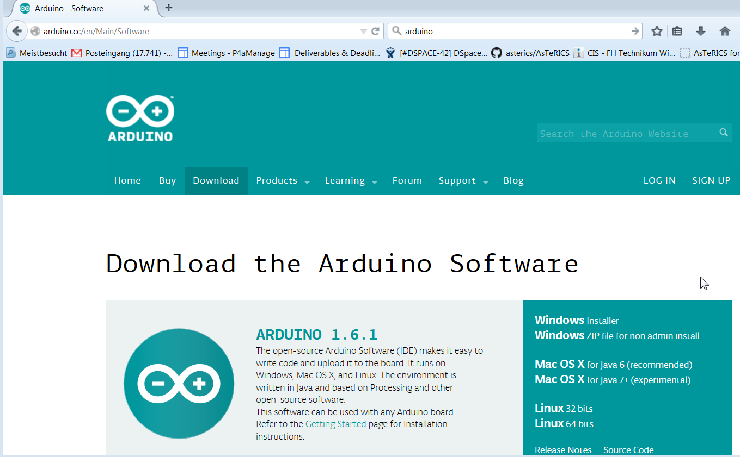

After installing the Arduino IDE, attach the microcontroller (Arduino Pro Micro) via an USB micro cable to a COM Port of your computer (the following screenshots show a Windows PC but the procedure is similar for Linux and MAC)

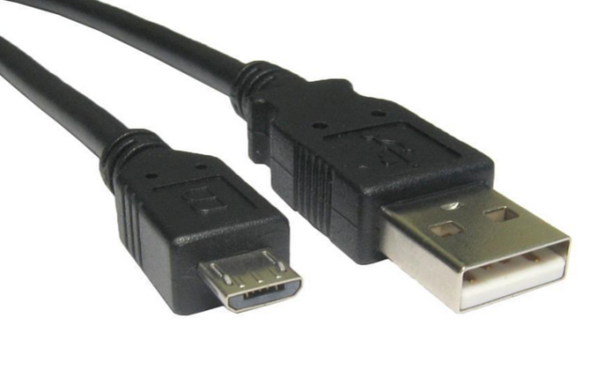

Connect this end to a USB port in your computer

Connect this end to the microcontroller

Figure 18: Micro USB cable

After making sure that the device is securely connected to the computer, the driver for the so-called “COM-Port” – for communication with the microcontroller – must be installed. Please follow the instructions here: <http://arduino.cc/en/Guide/ArduinoLeonardoMicro>

To check if the COM port has been installed, open the Windows Control Panel and the Device Manager:

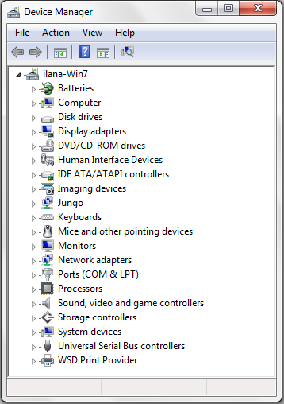

The COM port for your microcontroller should appear here. You can click on “Ports” to extend the list of ports. An entry like “Arduino Micro (COM7)” should appear. The number is arbitrary and gets automatically selected by your computer. Note this COM-Port number !

Figure 19: How to find the right com port

Now start the Arduino IDE and open the FABWare.ino file from the AsTeRICS download package. Select your **COM-port** number in the menu: **Tools-> Serial port**:.

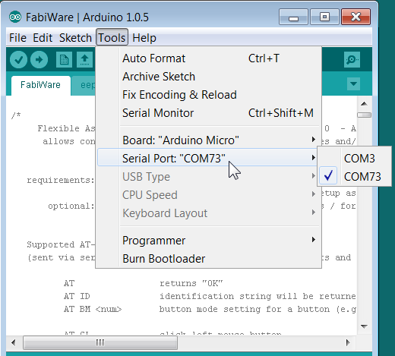

Then, select “**Arduino Micro**” in the menu **Tools->Board**:

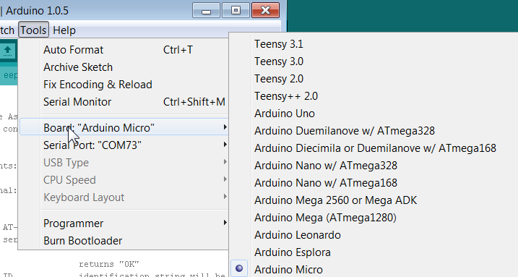

You should now be ready to compile the FABIWare source code into an executable firmware which will then be stored into the microcontroller. Perform all these steps by simply pressing the “Play”-Button in the Arduino IDE. After several seconds the message “done uploading” should appears. **Note this process must only be done once**, the firmware stays in the microcontroller also when you detach the power supply. In case of problems contact: [office@asterics-academy.org](mailto:office@asterics-academy.org) ;-)

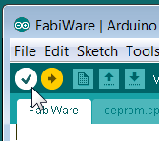 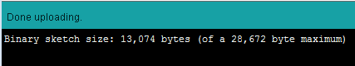

## Using the FABI GUI application

When the FABI firmware has been programmed into the microcontroller, you can use the FABI GUI application (currently only available for Windows) to configure your desired FABI functions. After starting FabiGUI.exe, the following window shall be displayed:

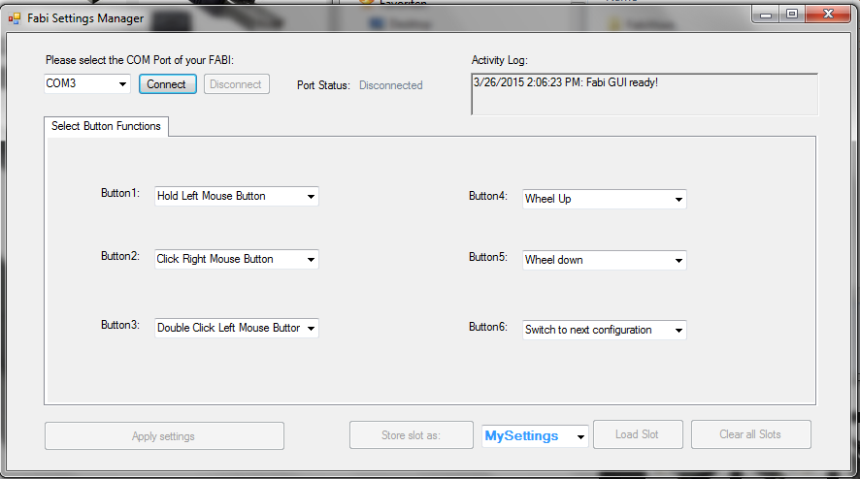

Figure 20: FABI user interface

#### Connecting the FABI device:

In order to be able to use the features of the FABI GUI, the FABI device must be connected to the application. To connect the device, follow the following steps:

1. Make sure your device is securely connected to your computer.
2. Select the appropriate COM port (communication port) in the combo box at the top of the application window. If the combo box does not show your noted COM Port number, please reconnect the device and wait for the COM ports to be updated, and then click on the drop menu to refresh the COM port list or restart the application.
3. Once the COM port is selected, click the Connect button on the right hand side of the combo box. When the device is connected, a confirmation message will appear in the activity log at the bottom of the application window, like the example below:

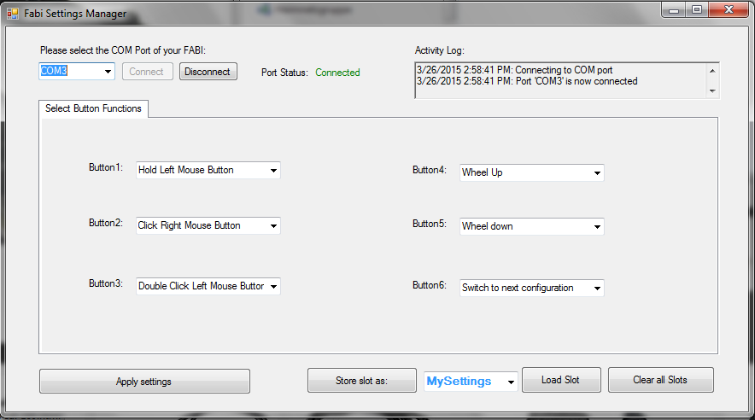

The combo-box dropdown selection for the desired COM Port and the “Connect” button

The activity log which shows current status messages and notifications

Figure 21: Program connected to the right port of the microcontroller

#### Port Status

The port status is located at the top / middle of the application window. It displays whether the device is currently connected or disconnected from the user interface. The functions of the user interface may only be used if the port status is “connected”.

#### Activity Log

The activity log is located at the top left corner the application window. It provides messages in accordance to the use of the application.

#### Applying Settings

The selected functions for the (up to) 6 buttons will be activated when you click “Apply settings”. Once the settings have been applied, you will receive a confirmation message in the activity log, and you will be able to use the FABI device with the new configuration.

#### Saving, Loading and Clearing Slots

If you have selected Button-Functions settings that you would like to use again, you may save them under a desired name in a memory slot of the microcontroller, so you can later re-load and use this configuration. Up to 4 memory slots are available. The memory slots will keep their content even if the microcontroller is unplugged from the USB cable/power supply. The first slot will be loaded and activated when you plug in the controller next time.

When you save a new slot, you can give it a name that will help you remember the configuration. To write in a new name, click into the text box on the right of the “Store Settings as” button. The drop down menu of this box also shows you the available slots which are stored in the controller.

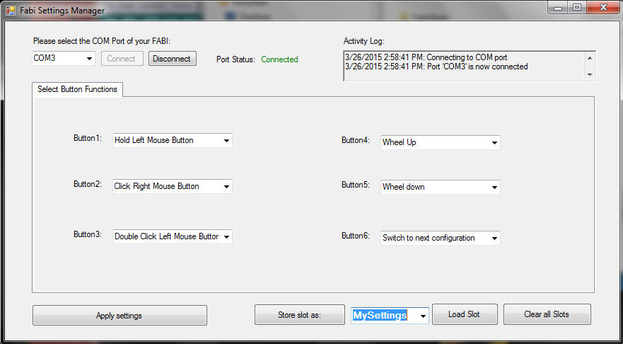

Here, the name of the currently active slot is displayed and new slot names can be entered !

Figure 22: Saving, Loading and Clearing Slots

Clicking will highlight the default text, as seen above. You may now the type the new name, which will replace the default text. After typing in the new name, click the “Store Settings as” button.

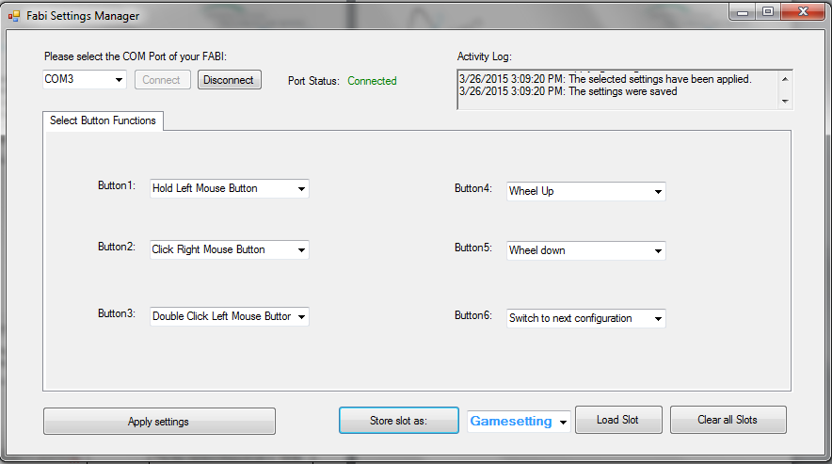

The new name in this example is “Game setting”, which can save the settings for the required input actions when playing a particular computer game

Click this button to save the configuration under the name entered in blue on the right

Figure 23: How to rename and store desired settings of single button functions

When your new configuration is saved, a confirmation messages will appear in the activity log:

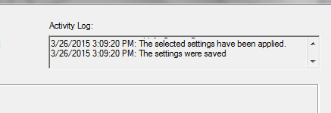

Figure 24: confirmation message, that new configuration is saved

When you store the settings, they are automatically applied (as you can see in the activity log shown in the above image). To save multiple settings configurations, simply repeat the above steps to save the new settings under a different name.

When you wish to use a particular configuration of the settings which you have saved before, expand the drop down menu by clicking the black arrow and choose the desired configuration. Once you have chosen it, click on “Load Slot”, and the saved settings will appear in the application.

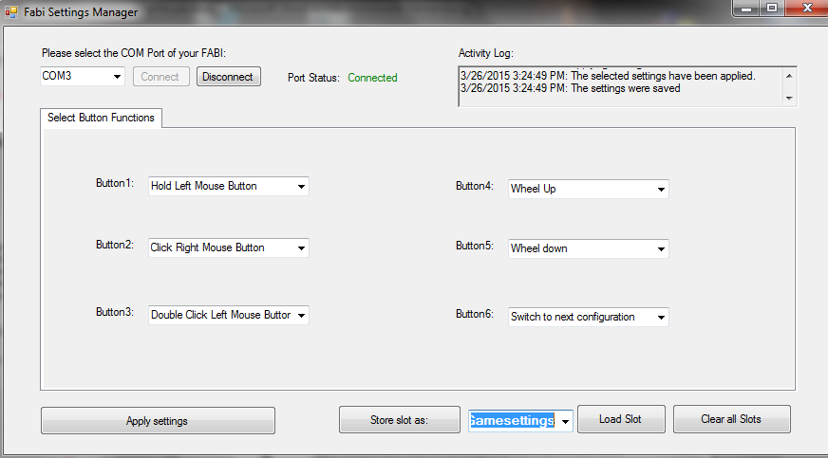

Click “Load Slot” to begin using the saved configuration

Click here to expand the drop down menu and select the slot with the desired configuration

Figure 25: Load and select desired configuration

If you would like to change the settings of a saved configuration, follow the next steps:

1. Load the slot (as described above) that you want to change.
2. After the slot is loaded, change the settings as you wish.
3. Click “Store settings as” to save the changes to the slot under the same name – the slot will be overwritten. You will receive the same confirmation messages in the activity log as when you save a slot for the first time (see image in previous page).

If you no longer wish to use any of the saved configurations, you may delete all of them at once by clicking “Clear all slots”.

## Selection of function for Button/Switch actions

In the FABI user interface you can associate up to 6 Button/Switch signals to different computer input control functions like“right mouse click”, “wheel up” or “Hold Mouse Button”. In the following chapter, the selection of these alternative actions is explained.

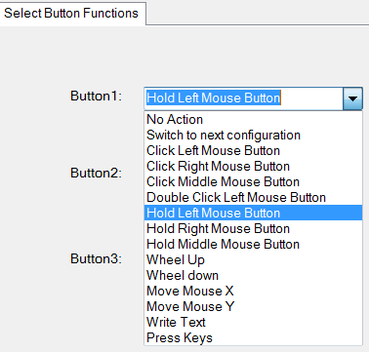

Figure 26: different alternative actions of the FABI GUI

#### 1: No action

If “No action” is selected from the function menu, then no action will be done when the button is pressed (yes: this also could be desired sometimes ;-)

#### 2: Switch to next configuration

This action is only relevant if you saved multiple FABI setting configurations to memory slots . Once you have multiple configurations saved, you can assign the action of switching between the configurations saved on different slots in the application.

#### 3: Click left/middle/right/ middle mouse buttons

With this function you can simulate a left/middle or right mouse click with the selected button

#### 4: Double click left mouse button

Double clicking the left mouse button may be necessary in cases such as opening a file. However, producing a double click with the regular click mouse button function may not be convenient, so you may assign a double click of the left mouse button instead.

#### 5: Hold left/middle/right mouse buttons

The click mouse button options imitate a quick mouse click, however sometimes it is necessary to continue pressing a particular mouse button (for example, when dragging a file, continuously pressing the left mouse click is necessary). For this purpose, the FABI user interfaces application allows assigning a button holding function to one of the stick movement directions.

#### 6: Wheel up/down

The options “Wheel up” or “Wheel down” emulate a scroll wheel, otherwise known as the mouse wheel. The picture below displays an example of a scroll wheel. Triggering the “Wheel up” option results in upwards scrolling, while “wheel down” results in downward scrolling.

#### 7: Mouse move X or Y

The cursor movements on the computer screen occur in both vertical and horizontal direction, where vertical movements are movements across the X axis and horizontal movements are movements across the Y axis. The “Move mouse X” and “Move mouse Y” emulate computer mouse movements and when triggered they result in mouse movements in the selected axis

These two options also require a speed parameter to indicate how quickly the cursor should move in each case. The input field for the speed parameter appears once the mouse move option is selected.

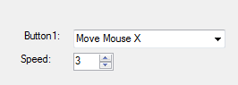

Speed parameters for each of the mouse movement options. Press the upwards or downward arrows to increase or decrease the speed, or press on the number to type in the speed manually

Figure 27: Screenshot of "Move Mouse X" action,   
the same principle is valid for Move Mouse Y

#### 8: Write text

The “Write text” option allows you to type a particular text excerpt each time you perform an action (for example, write “Hello” when you press the button).

When you select “Write text”, a blank text box will appear under the drop down menu as shown below: Click on the text box and type the desired text.

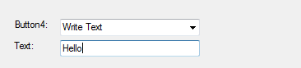

Write text here

Figure 28: Screenshot of "Write Text" action

In this example, “Hello!” will be written each time the button is pressed

#### 9:Press Keys

The “Press Keys” function allows you to perform a selected key command by pressing the button.

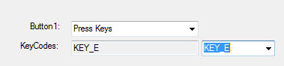

Choose desired key

Figure 29: Screenshot of "Press Key" action

In this example, “E” will be written each time the button is pressed.

## Appendix-A: List of needed Material

|  |  |
| --- | --- |
| **Microcontrollers**  and breadboard | * Arduino Pro Micro (or clone) - or alternatively Teensy 2.0++:   get it from: <http://www.aliexpress.com/snapshot/6508733198.html?orderId=65920185657484>  or <https://www.sparkfun.com/products/12640>  or <https://www.pjrc.com/teensy/>   * A small Prototyping-Breadboard get it from:   <http://www.aliexpress.com/popular/solderless-breadboard.html> |
| **Switch-solutions** |  |
| Connecting two wires | * isolated wires (if possible: black and colored) do not use stranded wire but single metal leads |
| Cardboard / foil switch | * Piece of cardboard * Copper foil/ aluminum foil (if possible: self-adhesive) * Sticky tape to fix the foil |
| Re-Using existing switches | * old switch (re-used from a device, light switch, etc.) * or: microswitch with lever |
|  |  |
| Stereo cable and jack plug connection:  (compatible to off-the-shelf assistive switches) | * Stereo audio cable * 3,5mm stereo or mono Jack plugs |

### Material for building and soldering your own FABI Box :

|  |  |
| --- | --- |
| **Basic equipment for soldering:** | * Soldering Iron + solder * Switching wire * Robust pad * Pliers (for cutting, strip isolation) * Vice |
| **FABI-Box** | * Plastic box (ca. 8cm x 5cm X 2cm) * Stand driller + 6mm drill * 6 3,5mm mono or stereo jack plugs * Double side tape to fix the controller in the box |

## 

## Appendix-B: Download Links and Contact

The AsTeRICS Academy Homepage:

<http://www.asterics-academy.net>

The AsTeRICS Project

<http://www.asterics.eu>

The AsTeRICS open Source GitHub Repository:

<https://github.com/asterics/AsTeRICS>